Name: ____________________________________________ Date:_______________________#_______
Slotted Notes – Plants and Photosynthesis
Basic Plant Anatomy
Flower – Attracting ________________ to help with pollination.
Stem – Holds the leaves up and _____________________ materials.
Leaves – Absorbs _________________ to produce ________________ for food.
Roots – ____________________ the plant, absorbs water and minerals.
Xylem – Carries water and minerals UP from the roots.
Phloem – Carries nutrients and glucose to the WHOLE plant.
Main Job of Leaves
Leaves allow a plant to ___________________ ________________.
They produce food using a ___________________ reaction called ___________________________.
Leaves take in: And produce:

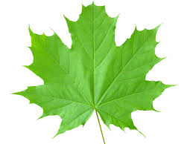

Light comes from the __________________.
Carbon dioxide comes from ______________________________.
Water comes from ___________________________.
Oxygen goes to __________________________.
Glucose goes to __________________________.
_____________________________________ traps the sunlight and gives leaves their green color.
Leaves have tiny holes on the bottom of them and these holes are called ________________.
Stomata allow gases to enter and exit the leaf. ____________ enters, __________ exits, and _________________ vapor exits.
Stomata can be opened or closed. They are surrounded by sausage-shaped _______________ _______________ that control it’s opening/closing. When guard cells swell with water, the stomata ________________. When guard cells lose water, the stomata ___________.

