ECMS Science Fair Packet
Due Dates
on Page 2
Tracks 6-2 & 6-4 December 16, 2015
Tracks 6-1 & 6-3 January 13, 2016
Dear Parents/Guardians,

The Science Fair is fast approaching so please take time to read this packet carefully. Guidelines, explanations, schedules and helpful hints are included. Your help and support are welcome, but please remember that the final project should reflect the problem solving and work of your child and must demonstrate their individual effort and design.

All 6th grade East Cary Middle School students will participate in the Science Fair. Your child will need a
tri-fold cardboard presentation board. These can be purchased at Target, Walmart, or any office supply store.
(If this is not an option for you, let your child’s science teacher know.)

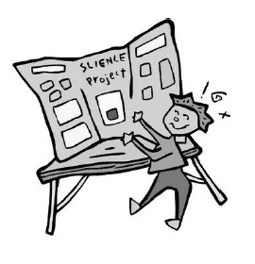
Please note: If your child is doing a project that includes materials that are messy, photographs should be taken and posted on the board instead of bringing in the actual materials. Also, no materials should be brought in that will decay quickly, or would pose a possible danger to other students.

If you have questions, please feel free to contact your child’s science teacher.

*Students are allowed to work with one other 6-1 student if they choose to
do so. Students, and parents, will need to sign the Partner Contract and
turn in to Ms. Haynie before Topics are due on Oct. 9th.

Track 1: Ms. Haynie lhaynie@wcpss.net

Estimados padres,
La Feria de Ciencias es rápida acercarse a lo por favor tome tiempo para leer este paquete. Se incluyen directrices, explicaciones, horarios y consejos útiles. Su ayuda y apoyo son bienvenidos, pero por favor, recuerden que el proyecto final debe reflejar la solución de problemas y el trabajo de su hijo y debe demostrar su esfuerzo individual y el diseño.
Todos los estudiantes de sexto grado East Cary Middle School participará en la Feria de Ciencias y presentar un experimento de la Feria de Ciencias. Su hijo necesita un tablero de cartón presentación de triple. Estos pueden adquirirse en Target, Walmart o cualquier tienda de suministros. (Si esto no es una opción para usted, que la ciencia maestra saber.)
Nota: Si su hijo está haciendo un proyecto que incluye materiales que son desordenados, fotografías deben ser tomados y publicados en el tablero en vez de traer en los materiales reales. Además, no debería señalarse ningún material que se desvanecerán rápidamente, o plantearía un posible peligro para otros estudiantes.
Si usted tiene preguntas, no dude en contactar con el profesor de Ciencias de su hijo.
Pista 1: Sra. Haynie lhaynie@wcpss.net

Schedule and Due Dates
*These Due Dates are for Rough Drafts of these parts. Students will be assessed with the rubric and given suggestions/corrections to make before creating their final board. The Final Grade will be determined by the Final Product – the completed Science Fair board turned in by Wednesday, December 2nd.

Part of Project | ROUGH DRAFT Due Date: | Point Value for this Part of Project | Facilitating Teacher Checking this Part of Project
Part A:  Choose a project category and decide on an experiment with a testable question | Friday, October 9th | 3 pts | Science Teacher  Unless otherwise informed
Part B:  - Title  - Defining the Problem | Friday, October 16th | 12 pts | Science Teacher  Unless otherwise informed
Part C:  - Background Information  - Bibliography  - Hypothesis | Friday, October 30th | 24 pts | Science Teacher  Unless otherwise informed
Part D:  - Procedures  - Materials | Friday, Nov. 6th | 12 pts | Science Teacher  Unless otherwise informed
Part E:  - Data  - Conclusion | Friday, Nov. 20th | 24 pts | Science Teacher  Unless otherwise informed
Part F:  - Abstract | Friday, Nov. 20th | 15 pts | Science Teacher  Unless otherwise informed
Part G:  - Display Board (Final Product) | Wednesday, December 2nd | 10 pts | Science Teacher  Unless otherwise informed

Total: __________ / 100 pts

All science fair projects need to follow the Scientific Method. This method is a systematic way that scientists inquire to find answers to their scientific questions.

- Make observations
- Ask a testable question
- Do research
- Conduct an experiment
- Analyze collected data
- Make a conclusion

Dear Student,

Below, we have outlined the steps you will take to complete this science fair project. It is important that you manage your time wisely. It will be your responsibility to work on your project along the way so that you do not have too much to do at the end!

Your Science Fair Project will showcase your understanding of the scientific method through an investigation of a problem or question. This is not an opportunity to just show how something works; it will be an opportunity for you to conduct a hands-on investigative experiment. It will be very important that you have a question or problem that is guiding your investigation. The key to a good and manageable investigation is to choose a topic of interest, then ask a “testable question.” Testable questions are those that can be answered through your hands-on investigation. The key difference between a general interest science question and a testable question is that testable questions are always about changing one thing to see what the effect is on another thing.

Please visit http://school.discoveryeducation.com/sciencefaircentral/ to learn more about the scientific method and how it applies to your Science Fair Project.

Elements to Include in Your Science Fair Project

Each project should be displayed on a tri-fold board that can be purchased at Target or any office supply store.
If a student needs help purchasing a board, he or she should let their teacher know. The information should
be neatly printed or written neatly and should show each step of the scientific process. Do not put your name on the front of the board. Your name, grade level, track, and science teacher’s name needs to be on the back of the board.
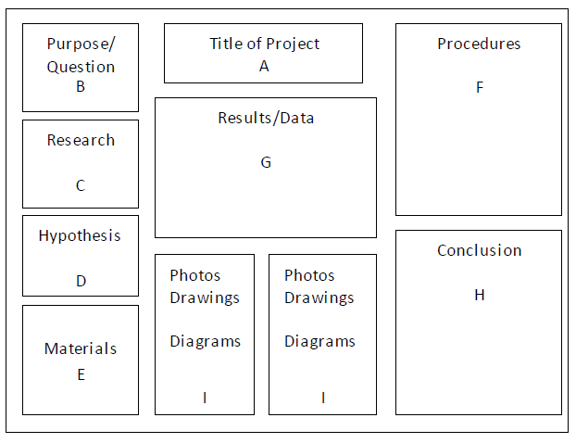
A. Title- What is the topic?

B. Purpose/Question - What is the question you want to answer? What is the reason for doing the experiment?

C. Research What research have you done on your topic? What have you learned that pertains to your experiment? Now, summarize what the research says and how it relates to your experiment.

D. Hypothesis - What do you think will happen and WHY?

E. Materials - List everything that is needed for the experiment.

F. Procedures - List the step-by-step instructions to carry out the experiment. These are directions that someone else could follow to complete the investigation.

G. Results/Data - Graphs, charts, sketches, photographs, etc. A summary of how the experiment turned out each time. Multiple trials should be carried out and recorded. Include an interpretation and analysis of the data.

H. Conclusions - What did your project show? How did it turn out? Was your hypothesis correct?

I. Photos/Drawings/Diagrams - This is your opportunity to add creativity and individuality to your board with relevant interesting information. Do not include personal photographs or pictures of the student.

J. Display You may display relevant items on the floor in front of your board. These items may not decay or be dangerous in nature. They should be able to fit inside a shoebox.

Basic Rules of a Fair

- Abstract - The abstract should be a maximum of 250 words, with the addition of three references.

- Size of Display - Maximum 48 inches wide, 48 inches high, 30 inches deep.

- Tissue - No human or animal tissues can be displayed. Teeth, hair, nails, dried animal bones, histological sections and mounted slides are allowed.

- Specimen - No taxidermy parts, preserved animals, or embryos can be displayed.

- Photographs - No visual presentations of surgical techniques, dissections, necropsies or other lab techniques depicting vertebrate animals or humans in other that everyday conditions can be displayed.

- Solid Waste - No solid waste, soil or other waste material may be displayed.

- Chemicals - No chemicals of any kind can be displayed.

- Sharp items - No syringes, needles, pipettes or other sharp instruments can be displayed.

- Controlled Substances - Poisons, drugs, controlled substances, explosives, hazardous devices or weapons cannot be displayed.

- Dry Ice - Dry ice or other solids that vaporize will not be displayed.

- Fire - No open flames or highly combustible materials are allowed.

- Tanks - Tanks, full or empty, used for storage of combustible gases or liquids are not to be displayed.

- Machinery - No unshielded belts, chains, pulleys or other hazardous moving parts shall be displayed.

- Lasers - Only class II lasers with proper warning labels displayed are allowed. Class III and IV are not allowed.

- Heat Source - Materials heated above 100 degree F are not allowed without adequate insulation.

- Electric Current - No unshielded high voltage equipment, large vacuum tubes, ray-generating devices, bare wires and knife switches carrying current at more than 12 v, or exposed sparks will be allowed.

- Embellishments - Awards, medals, business cards, or personal information are not allowed.

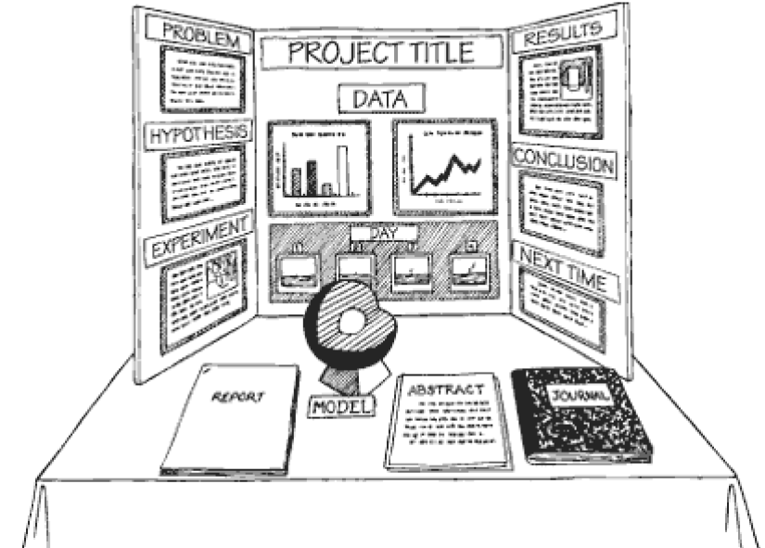
- Batteries - No open cell batteries may be displayed.

Project Categories
When registering for most fairs, you will need to assign your project to one of these five main categories:

Biological Science
- Microbiology - the study of all categories of microorganisms.
- Zoology - the study of the anatomy and physiology of animals, including, ichthyology, entomology,
ornithology, paleontology, herpetology
- Medicine and Health - the study of diseases and health of humans and animals.
- Behavioral Science - a study of human or animal behavior, archaeology, anthropology, opinion
surveys, psychology, social and community relationships.

Earth/Environmental Science
- Botany - the study of plant life, plant physiology and genetics, photosynthesis, horticulture, hydroponics.
- Environmental Science - projects that include study of ecology, and air, water and land pollution.
- Earth Science - including geology, mineralogy, meteorology, oceanography, geography, seismology.

Physical Science
- Physics - the study of optics, electricity, thermodynamics, acoustics, mechanics, states of matter, magnetism, quantum mechanics, laws of motion and energy.
- Chemistry - the study of the nature of matter at atomic and molecular levels; all branches of chemistry, including organic, inorganic, physical, analytical, polymer and metallurgical.

Technology/ Engineering
- Space Science - including astronomy, cosmology, and planetary science.
- Engineering - projects that apply scientific principles to practical applications of aeronautical, automotive, chemical, civil, electrical, environmental and mechanical engineering.
- Mathematics - the study and development of numerical and algebraic calculations, relationships that apply to all fields of mathematics.
- Computer Science - design and development of computer software and hardware, networking, graphics, or simulations.

Misc. Consumer Product Science
- Product Comparison

Part A: PROJECT CATEGORY

Write your chosen category here

Write a brief description of what you plan to do

Below Expectations  1 pt | Moderate  2 pt | Strong  3 pts

Part B:

TITLE
A title is a general or descriptive heading. An example of a creative title is “Purple Petunias,” or “Bullet Trains are Levitating”
Write your title here

DEFINING THE PROBLEM

The process of understanding the Scientific Method begins with observing or wondering about something in the world. It involves wondering how, why, and/or when something occurs. Discovery of things that are “new” usually begins with observation using the five senses: Sight, Sound, Smell, Touch, and Taste.

Key Words
Who What When Where Why How Explain Describe

Observation Questions
What do I wonder about it?
What do I want to find out?
Is it possible to research this topic?

After a topic is chosen, the students need to express their problem as a specific, open-ended question, such as:
“How does temperature affect the growth of mold on white bread?”
“Does the temperature during a storm cause more waves?”

Write your guiding question here

Rubric | Not Completed  0 pts | Below Expectations  1 pt | Moderate  2 pts | Strong  3 pts
Title is creative and clearly relates to the project

Problem statement is in the form of a question

Problem statement clearly states purpose of experiment
Written using complete sentences with correct spelling, punctuation, etc.

Total: __________ / 12 pts

Part C:

BACKGROUND INFORMATION & BIBLIOGRAPHY

After a topic has been chosen, the next step is research. Research is the process of collecting information from experience, knowledgeable sources, and experiments.

To get started, think about these questions:
What do I know about my topic?
What additional information would help me?
How can I use different sources of information to gather the information I need?

You need to use several different sources when conducting research.
Examples include: Books Magazines Professional Journals Newspapers Internet Interviews

You need to use reliable resources. Not all web sites have accurate information. Make sure the information obtained can be verified in more than one source. You need to check the relevancy of the information, how qualified the author is, and whether or not the information could be biased. You need to use .gov .edu .org and other reliable sources; search engines such as Wikipedia are not acceptable. You need a minimum of 3 sources.

HYPOTHESIS

A hypothesis is a prediction or simply an educated guess about the solution to a problem. It is important to conduct research and consider prior knowledge before formulating a hypothesis. You will test your hypothesis by performing an experiment.

To form a hypothesis, you should focus on the problem and make an “If then” statement about the problem. A hypothesis is a single statement about how two factors are related to each other. For example, “If the temperature in a room is changed, then mold will grow faster on white bread” OR “If the barometric pressure drops in a tropical depression, then a hurricane will form.”

Once the hypothesis is written, you need to write several facts from your research that explains why you believe your hypothesis to be correct.

Write your hypothesis here

Rubric on next page

Part C Rubric

Rubric | Not Completed  0 pts | Below Expectations  1 pt | Moderate  2 pts | Strong  3 pts
Uses appropriate sources to research topic. Bibliography: Lists at least 3 sources

Uses a variety of types of sources, such as a website, magazine, article, encyclopedia, and/or book.

Bibliography includes source descriptions (website address, book title, author, page #, publisher, publisher city, publish date)

Hypothesis is written in If/Then form

Background information (research) is typed in an outline form bulleting main ideas and factual information.
(who, what, when, where, how)
Outline of background information includes facts/information to support hypothesis

(Meaning research is focused and on topic)
Written using complete sentences with correct spelling, punctuation, etc.

Non-plagiarized. All writing is written using students own words

Total: __________ / 24 pts

Part D:

PROCEDURES

A procedure is a way of doing something or getting something done. The procedures are written in complete sentences. They are listed and numbered. A procedure needs to be written clearly enough so that someone else can perform the same experiment. This is a step-by-step guide to doing the experiment. For example:

1. Fill one graduated cylinder with 75-ml of distilled water.
2. Weigh out .02 grams of Copper
3. Place .02 grams of Copper in one plastic cup.
4. Weigh out 1 gram of Sulfide.
5. Place 1 gram of chloride in the same plastic cup.
6. Add 75-ml of distilled water to the plastic cup.

MATERIALS

Materials are the substance or substances from which something is or can be made. Materials are tools or apparatus needed to perform a certain task.

Materials that are used during an experiment need to be listed. The amounts of the materials need to also be listed. Below is an example of a materials list:

- 12 300-ml Plastic cups at room temp
- 1 250-ml graduated cylinder
- 1 stopwatch
- 30 small paper plates
- 1 Triple Beam Balance
- 1 Scale
- 5 Grams Copper (Cu)
- 15 Grams Sulfide (S2)
- 1,000-ml distilled water

.

Rubric | Not Completed  0 pts | Below Expectations  1 pt | Moderate  2 pts | Strong  3 pts
Procedure is clear and precise (e.g. steps are in order, easy to follow, etc.)

Procedure is typed in complete sentences with proper spelling/grammar

All materials are clearly listed

Amounts or quantity used are included in list of materials

Total: __________ / 12 pts

Part E:

DATA (Must include a data chart and/or graph with a written analysis of the data in paragraph form)

Data is what is observed. Data is listed in the form of a table. The data is then used to make charts or graphs, so that you can clearly see the results from the data.

The student needs to record their data collected through measurements or observations in a clearly labeled data table. The student will use the data table to construct the appropriate type of graph to provide a pictorial representation of what happened during the experiment.

The student will write and explain the variables of the experiment. A variable is anything that affects your topic and can or cannot be changed in your experiment. There are three types of variables: dependent, independent, and control. A dependent variable is the change that happens in your experiment or what you are measuring. The independent variable is the one thing that that you can change in your experiment to figure out what impact it has on the topic you are studying. The control variable is the variable that is not changed; it shows what happens when the independent variable is not applied.

An easy way to identify the variables in an experiment is to fill in the blanks of the following sentence,

The _________ depends on _________

For example, in an experiment testing the effects of temperature on the growth of bread mold would be…..

The growth of mold depends on the temperature of a room.

The growth of mold is the dependent variable and the temperature is the independent variable. You will be changing the temperature of the room so the growth of the mold will be affected. A control would be a room that is always at the same constant set temperature with no changes.

CONCLUSION

The conclusion is the full explanation of what your project was and what it showed you. The conclusion is written in paragraph form. A conclusion will answer your problem and your hypothesis, based on the data collected during your experiment. It must state whether or not the data supports or rejects the original hypothesis.

In addition, you will explain any problems you had conducting the experiment and how you would correct them in the future. You will need to explain what you would do differently if you did the experiment again. If your results are different then you expected you need to discuss this. You also need to discuss any other questions you have now after doing the experiment.

Rubric on next page

Part E Rubric

Rubric | Not Completed  0 pts | Below Expectations  1 pt | Moderate  2 pts | Strong  3 pts
Data recorded using charts, graphs, tables, photos, etc.
Charts, graphs, tables, etc. are organized and easy to read
Identified dependent, independent, and control variables
Data analysis includes an interpretation of data (what was found, why)
Conclusion states if hypothesis was correct/incorrect with explanation
Conclusion includes limitations (problems) of experiment
Conclusion includes recommendations for future experiments
Are written using complete sentences with correct spelling, punctuation, etc.

Total: __________ / 24 pts

Part F:

ABSTRACT

The abstract is a simply a brief summary of the experiment, written in paragraph form. It should summarize the purpose of the experiment, the procedures used, the results, and conclusions. It should not exceed 250 words.

Rubric | Not Completed  0 pts | Below Expectations  1-2 pt | Moderate  3-4 pts | Strong  5 pts
Abstract is completed (includes brief summary of purpose, procedures and analysis, results, and conclusions; less than 250 words)

Are written using complete sentences

Are written with correct spelling, punctuation, etc.

Total: __________ / 15 pts

Part G:
SCIENCE FAIR BOARD

Nothing but paper and pictures should be on boards. It is preferred to use pictures of objects/materials instead of attaching object/materials to the boards.

Any photos must be credited (e.g. photo taken by……) and copyrighted pictures are not permitted without permission.

Rubric | Not Completed  0 pts | Below Expectations  1-2 pt | Moderate  3-4 pts | Strong  5 pts
Board is the appropriate size and is set up as instructed (using the proper format)
Data section is neat, clear and well organized (includes tables, graphs, etc.)

Total: __________ / 10 pts

Science Fair Partner Contract

I, _____________________________(Student Name), have chosen to work with ___________________________________(Partner Name) for the Science Fair Project. Both myself, and my parents/guardians, understand that the grade the project receives will be given to BOTH partners.

Partners must able to:

- Work on the project outside of school together.
- Work collaboratively together (one partner does not do more than the other).
- Work through any conflicts that may arise between each other (Ms. Haynie will not play referee between partners).
- Continue to work together until the very end of the project. (Do not decide mid-way through that you would rather work independently).
- Understand that your final product is a reflection of your work together and that you will each receive the same grade.

By signing below, you are acknowledging your partner responsibilities for this project. Please make sure you are choosing your partner wisely.

Student Signature: _______________________________________________

Parent/Guardian Signature: ______________________________________

Please separate this page from your packet. Staple your signed contract with your partner’s signed contract and turn into the silver tray in the Science classroom by Friday, October 9th.

